CWWS Fund - Capital Improvement Projects
Project Name:  Stonebridge Lift Station (Construction) | Department:  Public Works - Utilities
Type of Project:  New Construction | Contact:  Chuck Soules
Total Project Cost:
$1,572,000

Description:
HDR conducted an evaluation of the existing Stonebridge Pump Station (PS) to determine the necessary capacity improvements for handling increased water flow as the watershed continues to develop. On June 29, 2023, the City conducted a drawdown test on the existing Stonebridge Pump Station. The test revealed an operational issue affecting the station's pumping capacity. Possible factors contributing to this problem include clogged pumps, faulty seals in the discharge pipe, defective check valves, or a restriction within the existing 4” force main.
Both the existing Daycare and Stonebridge pump stations are inadequate for managing the anticipated increased water flow from future watershed development. Instead of individually upgrading and maintaining both pump stations, a proposal was assessed: the removal of the Daycare Pump Station and directing the flow through a gravity sewer to a newly designed and larger Stonebridge Pump Station. It's noted that the 4” force main connecting Stonebridge to Daycare should ideally handle the expected peak flow. However, given the results of the drawdown test, it's possible that there's a blockage or constraint within this force main, or potential issues at the pump station that necessitate further investigation.
Recommendations involve considering an alternative, such as replacing the current 4” force main with a new one if a blockage or restriction is identified as the root cause of the problem. As part of this approach, the existing Daycare and Stonebridge pump stations would be decommissioned and replaced with a new, larger Stonebridge pump station situated adjacent to the existing setup. In FY2025, $72,000 of project costs were expensed.
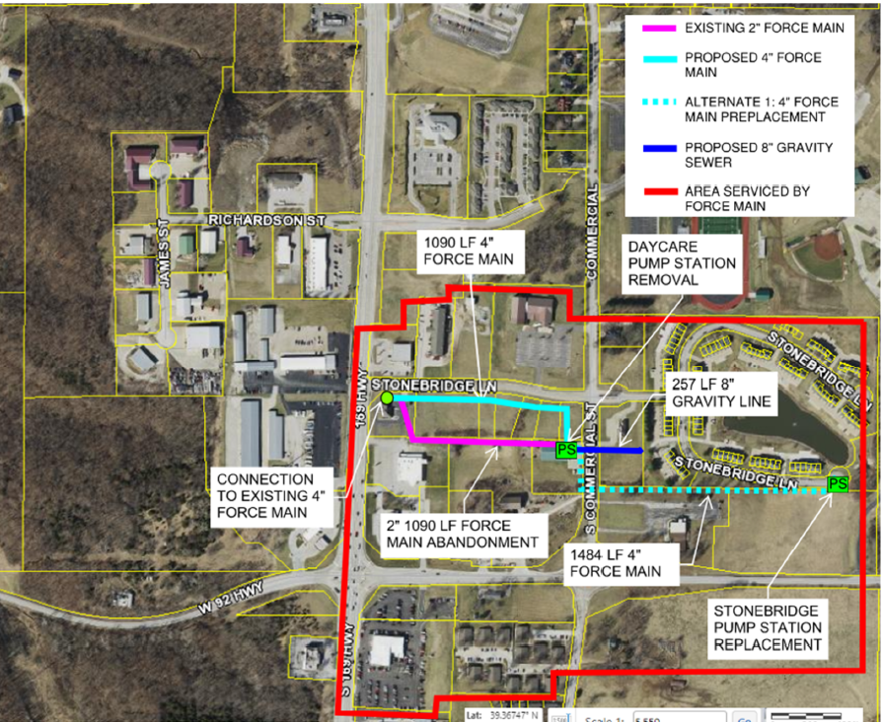
Justification:
The project is needed for capacity improvements in the southern portion of Smithville and will allow staff to decommission lift stations that are under capacity.
Impact on Operating Costs
This will be a new lift station which will require future maintenance and operational costs.
Planned Expenditures
 | FY2026 | Total
Engineering | $200,000 | $200,000
Construction | $1,300,000 | $1,300,000
Total | $1,500,000 | $1,500,000

Funding Sources
 | FY2026 | Total
CWWS | $1,500,000 | $1,500,000
Total | $1,500,000 | $1,500,000

